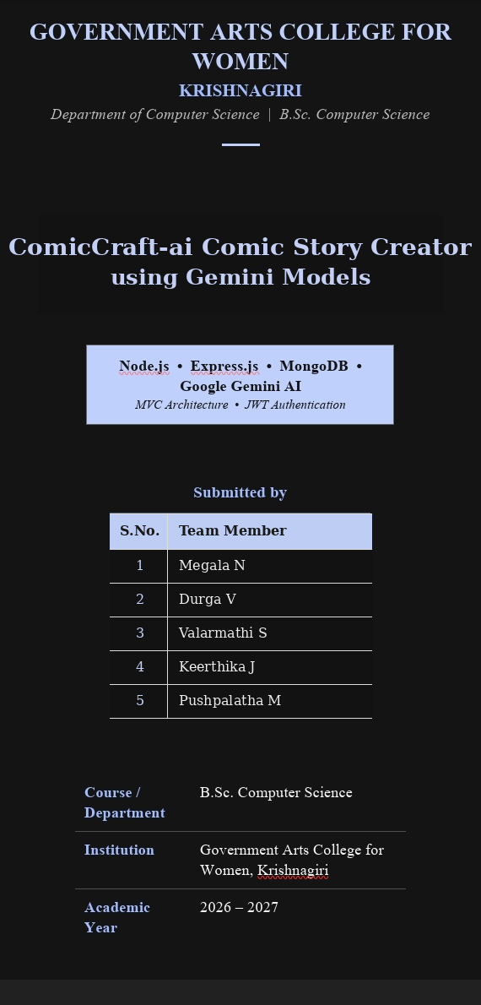

ComicCraft
AI Comic Story Creator using Gemini Models
Project Documentation

1. Project Description
ComicCraft is a web-based application that uses AI to generate personalized comic book stories and illustrations from user-provided prompts. It is built with FastAPI and integrates Google's Gemini models alongside Stable Diffusion, automating the creative process of generating storylines, dialogues, and comic-style artwork.
The application accepts user inputs such as a story prompt, main character name, setting, tone, and art style, and produces a panel-by-panel comic strip. Users can preview the generated comic directly in the browser and download the complete comic as a structured PDF containing both illustrations and narration.
A lightweight HTML/Jinja2 frontend and an efficient Stable-Diffusion-based image pipeline (via Hugging Face Diffusers) keep each generated story cohesive and visually engaging, making comic creation accessible to non-artists and casual users alike.

2. Objectives
- Allow users to describe a comic idea in plain language and receive a complete, illustrated comic strip.
- Let users customize character name, setting, tone, and art style, and regenerate the comic to match their vision.
- Automatically generate a structured, panel-by-panel outline, full narration/dialogue, and matching illustrations.
- Export the finished comic as a downloadable, professionally formatted PDF.
- Provide both a browser-based UI and JSON API endpoints for programmatic use.

3. Technical Architecture
The application follows a layered architecture with a clear separation between the frontend, backend routing, and AI-integration modules:
Component | Responsibility | Key File(s)
User (Browser) | Submits story details via the web form | index.html
FastAPI Backend | Receives requests and coordinates the pipeline | app/main.py, app/routes.py
AI Comic Generation Logic | Calls Gemini + Diffusers models in sequence | gemini_flash.py, gemini_pro.py, image_generator.py
Layout Builder | Combines images and story text into a per-panel layout | layout_builder.py
Comic Exporter | Compiles the layout into a downloadable PDF | exporters.py
Preview / Success Pages | Renders the comic and the export confirmation | comic_preview.html, export_success.html

Request flow: Browser → FastAPI (main.py) → routes.py → Gemini Flash (outline) → Gemini Pro (narration) → Stable Diffusion (images) → layout_builder.py → exporters.py (PDF) → comic_preview.html → export_success.html.

4. Prerequisites
- FastAPI framework knowledge
- Python programming proficiency
- HTML, CSS, and Jinja2 templating basics
- Familiarity with the Google Gemini Generative AI API
- Hugging Face Diffusers / Stable Diffusion basics
- PyTorch fundamentals
- PDF generation with FPDF
- Git version control
- Python virtual environment management (venv / pip)

5. Project Structure
comiccraft/
├── app/
│ ├── main.py # FastAPI app entrypoint
│ ├── routes.py # All route handlers
│ ├── gemini_flash.py # Panel outline generation (Gemini Flash)
│ ├── gemini_pro.py # Story narration & dialogue (Gemini Pro)
│ ├── image_generator.py # Panel illustration (Stable Diffusion)
│ ├── layout_builder.py # Combines images + text into a layout
│ └── exporters.py # Exports the comic to PDF (FPDF)
├── templates/
│ ├── index.html
│ ├── comic_preview.html
│ └── export_success.html
├── static/
│ ├── panels/ # Generated panel images
│ ├── exports/ # Exported comic PDFs
│ └── fonts/ # Unicode TTF font for PDF export
├── requirements.txt
├── .env.example
└── README.md

6. Module-wise Explanation

6.1 Generate Structured Comic Panel Outline
Function: generate_outline() | File: gemini_flash.py
- Uses the Gemini Flash model to generate a structured 5-panel comic outline from the user's story prompt.
- Each panel contains a panel number, title, scene description, and an image generation prompt.
- The model is instructed to respond only in strict JSON; markdown fences are stripped and the structure is validated before use.

6.2 Generate Comic Story Narration and Dialogue
Function: generate_story() | File: gemini_pro.py
- Uses the Gemini Pro model to expand the panel outline into a full comic-style story.
- Produces engaging narration and character dialogue for every panel.
- Returns a single formatted text block containing all panels' stories, later split per panel by the layout builder.

6.3 Generate Comic Illustrations from Prompts
Function: generate_image() | File: image_generator.py
- Uses Stable Diffusion (Hugging Face Diffusers) to create a comic-style image from each panel's image prompt.
- Sanitizes the prompt into a safe filename and saves the generated image under static/panels/.
- Returns the file path of the saved image for use by the layout builder.

6.4 Organize Comic Panels into a Layout Structure
Function: build_comic_layout() | File: layout_builder.py
- Splits the full story text back into per-panel segments.
- Matches each generated image with its corresponding panel title, scene description, and story text.
- Outputs a list of dictionaries — one per panel — ready for rendering or PDF export.

6.5 Export Comic Panels and Story into PDF
Function: save_pdf() | File: exporters.py
- Compiles the full comic layout into a multi-page PDF using the FPDF library.
- Places each panel's image and narration on its own page, with a Unicode font fallback to Arial when unavailable.
- Saves the PDF into static/exports/ with a timestamped filename and returns its path.

7. FastAPI Routes
Route | Purpose
GET / | Loads the homepage with the comic input form
POST /generate | Handles form submission and runs the full AI pipeline, returning the comic preview page
POST /generate-comic/json | JSON API route — same pipeline, returns layout data and PDF path for API clients
GET /export-success | Displays a success confirmation page after PDF download
GET /test-image | Developer utility route to test image generation independently

8. Setup and Local Deployment

8.1 Create a Virtual Environment
python -m venv comiccraft-env
# Windows
comiccraft-env\Scripts\activate
# macOS/Linux
source comiccraft-env/bin/activate

8.2 Install Dependencies
pip install -r requirements.txt

8.3 Configure Environment Variables
Create a .env file with the required API keys:
GEMINI_API_KEY=your_gemini_api_key_here
HF_API_KEY=your_huggingface_api_key_here

8.4 Run the Server
uvicorn app.main:app --reload

Visit http://127.0.0.1:8000 -> ComicCraft homepage
Visit http://127.0.0.1:8000/docs -> Interactive API documentation

9. Sample Scenarios

Scenario 1 — Personalized Story Generation
A user enters a prompt such as “A brave fox exploring an enchanted forest” along with a character name, setting, tone, and art style. Gemini Flash generates the panel outline, Gemini Pro writes the narration, and Stable Diffusion illustrates each panel — producing a cohesive, personalized comic strip.

Scenario 2 — Iterating on Mood and Style
The user changes the tone to “funny” and the art style to “comic book.” Resubmitting the form regenerates the entire pipeline with new prompts, letting the user iterate on mood and visual style until it matches their vision.

Scenario 3 — Downloading the Comic
- Layout Binding: layout_builder.py assembles each panel's title, image, and text into a structured layout.
- PDF Generation: exporters.py compiles the comic into a PDF using FPDF, saving it with a timestamped filename.
- Export Success: the user is shown a confirmation page after the PDF download completes.

10. Conclusion
ComicCraft demonstrates the creative potential of AI-driven comic generation by combining Gemini Flash and Gemini Pro for storytelling with Stable Diffusion for illustration. It provides an end-to-end experience — from prompt to a downloadable, illustrated PDF comic — through a simple web interface, making comic creation accessible to non-artists and hobbyists alike.
The modular architecture (separate modules for outline generation, narration, image generation, layout building, and PDF export) makes it straightforward to extend the project with features such as user accounts, comic libraries, or multi-page story arcs in the future.

